**Library Management System**

**Introduction:**

Libraries are vital institutions that foster knowledge sharing, education, and intellectual exploration. In today's digital age, managing a library requires efficient tools to organize vast collections, streamline workflows, and enhance user experiences. A library management system (LMS) serves as the backbone of these operations, providing a comprehensive software solution for libraries of all sizes.

**Core Functionalities:**

* **Cataloging and Collection Management:** LMS facilitates the creation and maintenance of a digital catalog, allowing librarians to efficiently record book details, manage inventory levels, and track loaned and available resources.
* **Patron Management:** The system streamlines patron registration, tracks membership details, and automates borrowing and return processes. Patrons can conveniently search the catalog, reserve books, and manage their accounts online.
* **Circulation Management:** Borrowing and returning books become effortless with barcode scanning and automated due date notifications. This reduces manual tasks for librarians and ensures timely return of materials.
* **Reporting and Analytics with Management Access:** LMS generates valuable reports on book usage, borrowing trends, membership statistics, and overdue items. Librarians can create and customize reports for internal analysis, while the system also empowers them to generate comprehensive reports for library managers. These insights enable informed decision-making regarding collection development, resource allocation, and service optimization.
* **Search and Discovery:** Users can search the library catalog by title, author, genre, or keyword, making it easier to find relevant materials. Advanced search functionalities can further refine results based on specific criteria.

**Benefits of an LMS:**

* **Increased Efficiency:** Automating routine tasks frees up librarian time for knowledge-based services like reader's advisory and research assistance.
* **Enhanced Accessibility:** Patrons can access the library catalog, renew loans, and manage accounts remotely, extending library services beyond physical boundaries.
* **Improved Organization:** A centralized system ensures accurate and up-to-date information about library resources, promoting better collection management.
* **Informed Decision-Making:** Data-driven insights from reports help librarians cater to user needs, optimize book acquisitions, and improve overall library services. Management can leverage comprehensive reports to assess library performance, identify areas for improvement, and allocate resources strategically.

**Conclusion:**

A library management system is an indispensable tool for libraries in the 21st century. By automating workflows, enhancing accessibility, and providing valuable data for both librarians and managers, an LMS empowers libraries to operate efficiently, deliver exceptional services to patrons, and cultivate a thriving environment for learning and exploration.

1. **Context Diagram**

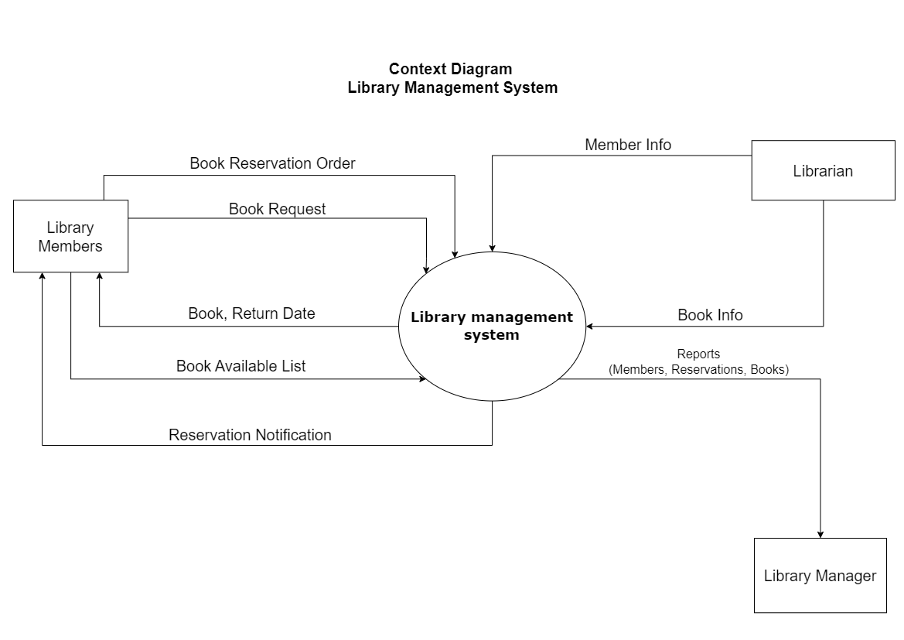

1. **Level-0 (DFD) Diagram**

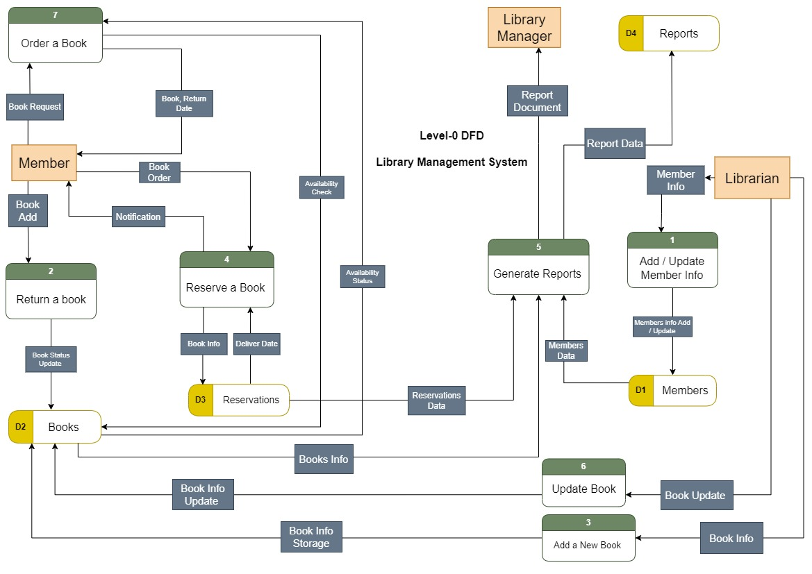

1. **Use Case Diagram**

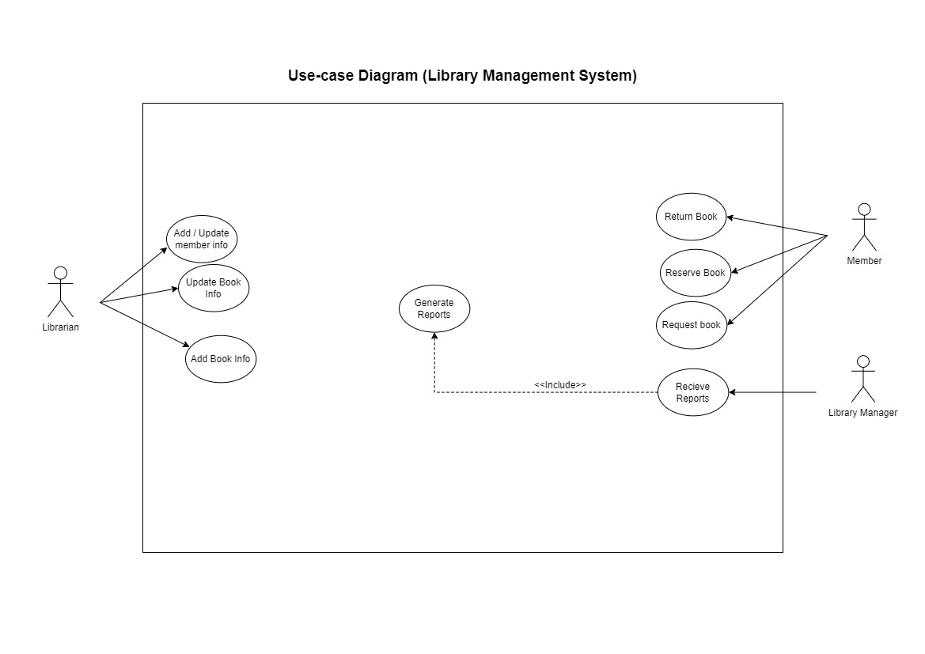

1. **Use Case Analysis**

**Use Case analysis for** **Order a book**

|  |  |
| --- | --- |
| **Use Case Name:** | Order a book |
| **Actor(s):** | Member |
| **Description:** | This use case describes the process of a member to order a book. |
| **Typical Course of Events:** | |  |  | | --- | --- | | **Actor Action** | **System Response** | | **Step1:** Member enter to library management system.  **Step 3**: The Member enters login credentials (library card number, pin).  **Step 5**: Member selects "Order Book" option from menu, then enters search criteria (title, author, etc.).  **Step 7**: Member log out of the system. | **Step 2**: System displays login screen.  **Step 4**: System validates credentials, if it Succeed, System displays main menu with options. Else System displays error message, prompts member to renter credentials.  **Step 6**: If the search process is successful, the order will be confirmed, the delivery date will be determined, and the data will be saved in the data store, else the member must choose, exit the system or reserve the book. | |
| **Alternate Courses:** | **Step1**: If the book Unavailable Call use case (Reserve a Book).  **Step2**: The renter can choose to cancel their order at any point before the book becomes available. The system would update the book's availability status accordingly. |
| **Precondition:** | Orders can only be submitted by member system. |
| **Post condition:** | Member order has been recorded. |

**Use Case analysis for** **Add new book**

|  |  |
| --- | --- |
| **Use Case Name:** | Adding a new book |
| **Actor(s):** | Librarian |
| **Description:** | This use case describes the process of a librarian adding a new book to the library's collection. |
| **Typical Course of Events:** | |  |  | | --- | --- | | **Actor Action** | **System Response** | | **Step1**: The Librarian navigates to the "Add New Book" section of the library management  system.  **Step 3**: The Librarian enters the required information about the new book into the system.  **Step 5**: Once the information is entered and validated, the Librarian confirms the addition of the new book to the system.  **Step 7**: The system updates the inventory records to reflect the addition of the new book, including quantity available, location, and any other relevant details. | **Step 2**: The system displays a form or prompts the Librarian to input the details of the new book, such as ISBN, title, author, genre, publication date, etc.    **Step 4**: The system validates the entered information to ensure it meets the required criteria.  **Step 6**: The system adds the new book to the library's collection and assigns it a unique identifier. | |
| **Alternate Courses:** | **Step1**: If the Librarian enters invalid or incomplete information, the system displays an error message and prompts the Librarian to correct the input.  **Step2**: At any point before confirming the addition, the Librarian may choose to cancel the process, returning to the previous screen or exiting the "Add New Book" section altogether. |
| **Precondition:** | • The Librarian is logged into the library management system.  • The Librarian has appropriate permissions to add new books to the system. |
| **Post condition:** | The new book is successfully added to the library's collection. |

**Use Case analysis for** **Generate reports**

|  |  |
| --- | --- |
| **Use Case Name:** | Generate reports |
| **Actor(s):** | Librarian |
| **Description:** | The system collects information related to books, customers, and reservations from the data stores and sends these reports to the manager. |
| **Typical Course of Events:** | |  |  | | --- | --- | | **Actor Action** | **System Response** | | **Step1**: Librarian enter to library management system.  **Step 3**: The Librarian enters login credentials (library card number, pin).  **Step 5**: Librarian selects "Generate Reports" option from menu, then Chooses the desired report type and define format.  **Step 7**: Librarian log out of the system. | **Step 2**: System displays login screen.  **Step 4**: System validates credentials, if it Succeed, System displays main menu with options. Else System displays error message, prompts member to renter credentials.  **Step 6**: System collects reports from data store to generate the report based on selection and insert reports in data store. | |
| **Alternate Courses:** | **Step 1**: The librarian can choose to cancel the report generation process at any point.  **Step 2**: The librarian can log out of the system at any point. |
| **Precondition:** | • The system has access to the data stores containing books, customer, and reservations information  • The manager has requested a report on the library's current state |
| **Post condition:** | The manager has received reports containing information about books, customers, and reservations. |

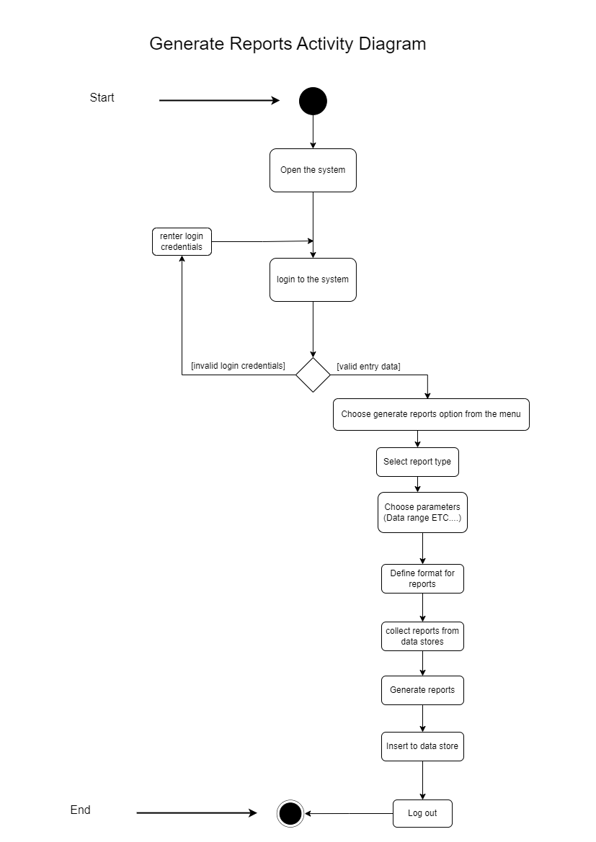**5) Activity Diagram**

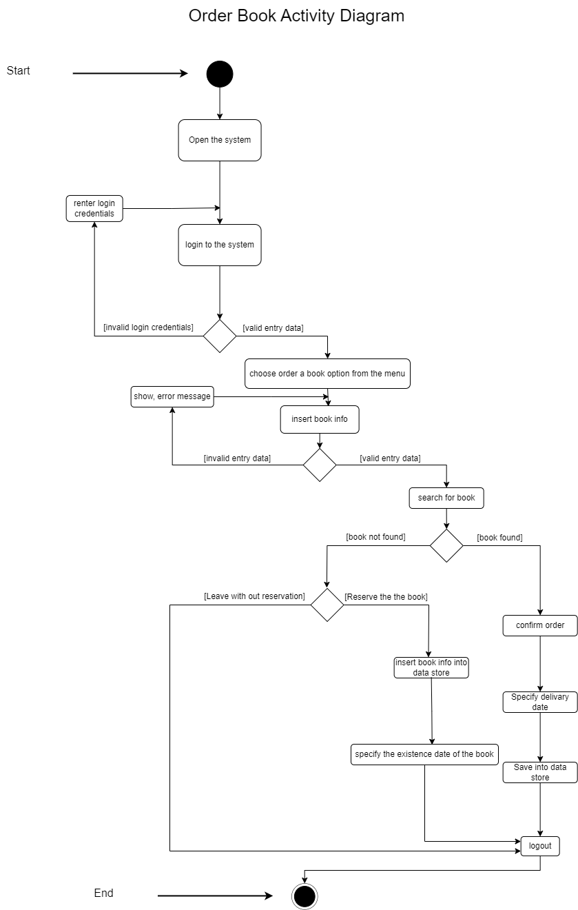

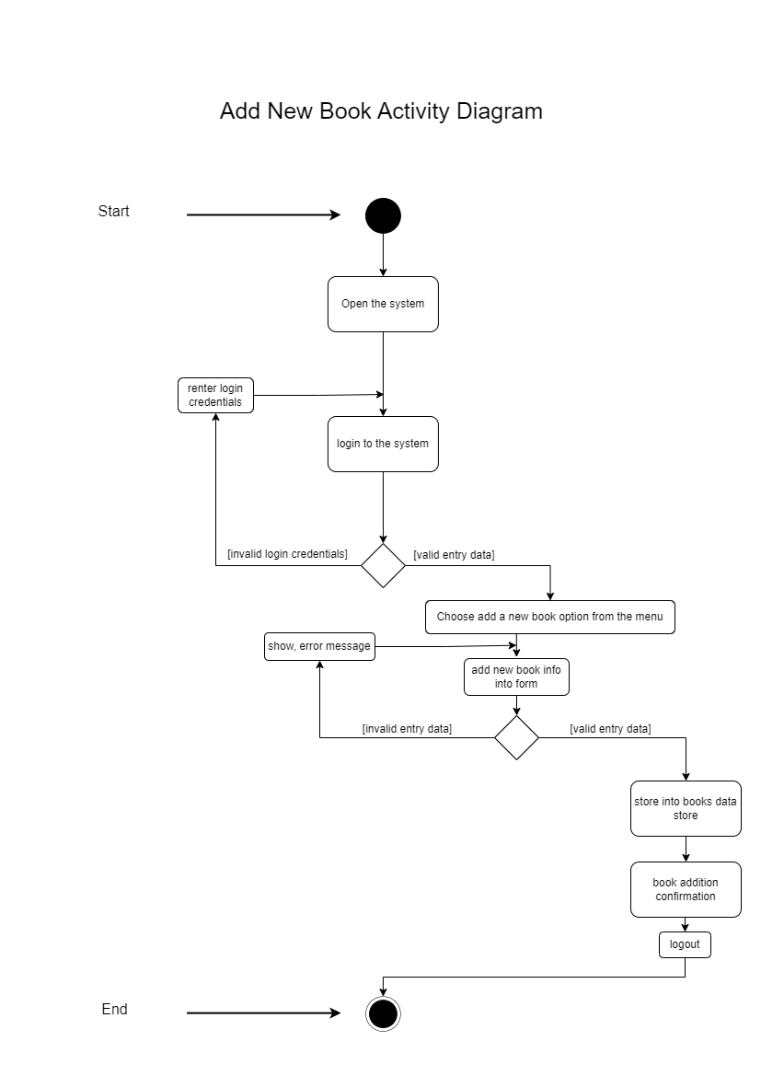

**6) System Sequence Diagram (SSD)**

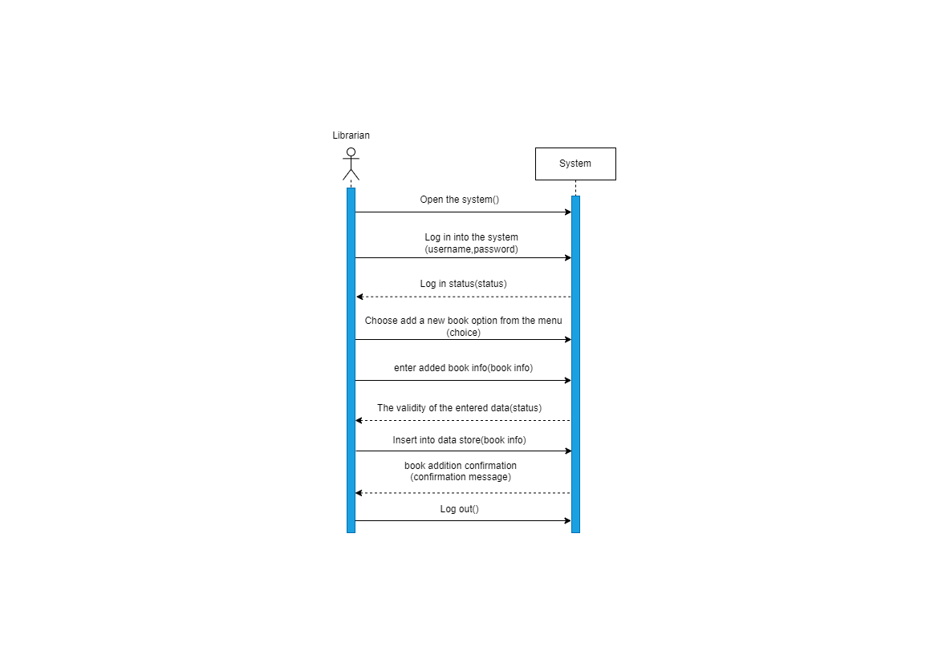**Add new book**

**Generate reports**

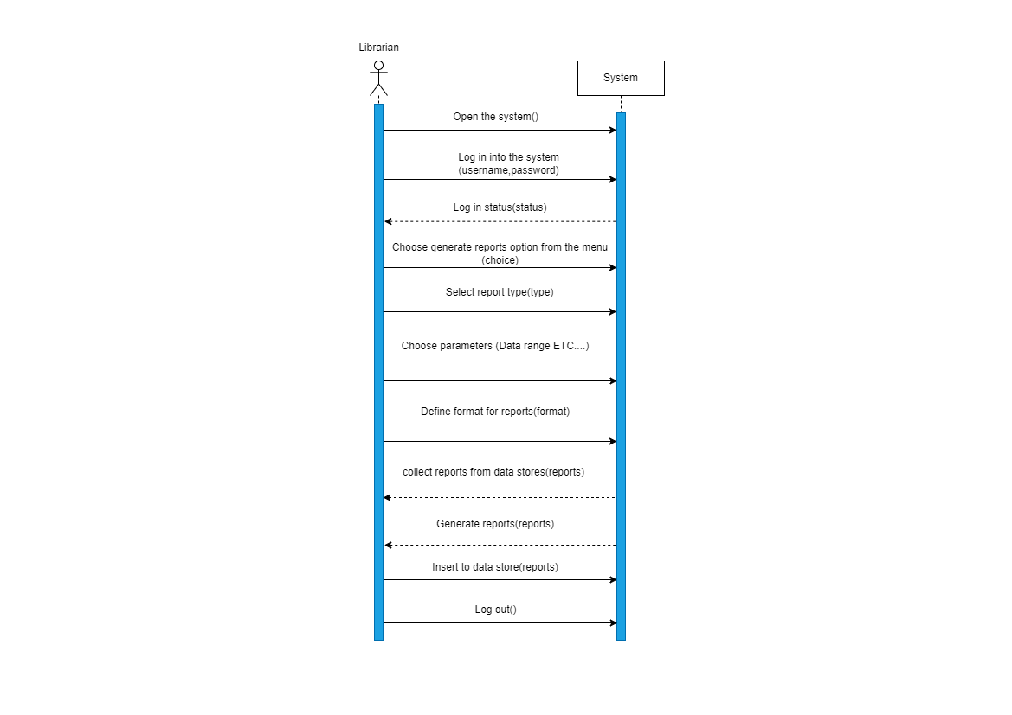

**Order a book**

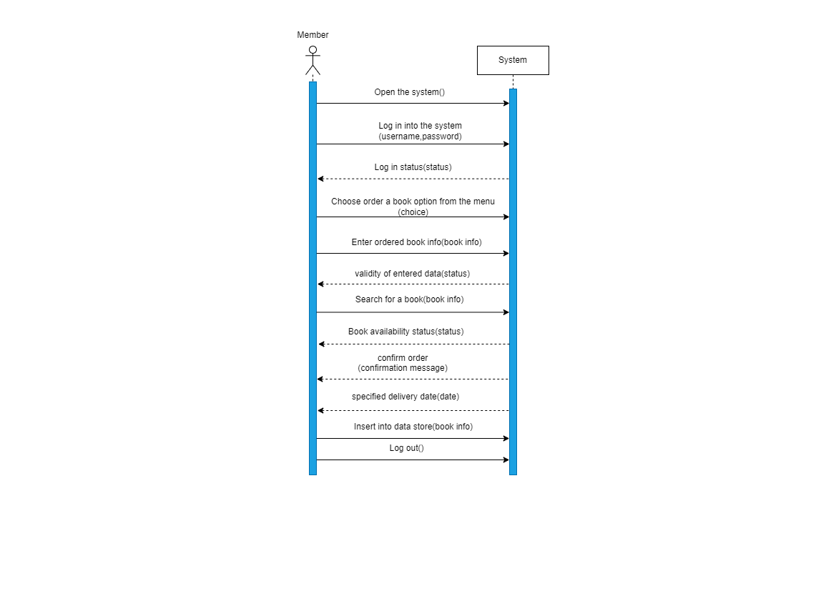

**7) Sequence Diagram (SD)**

**Generate reports**

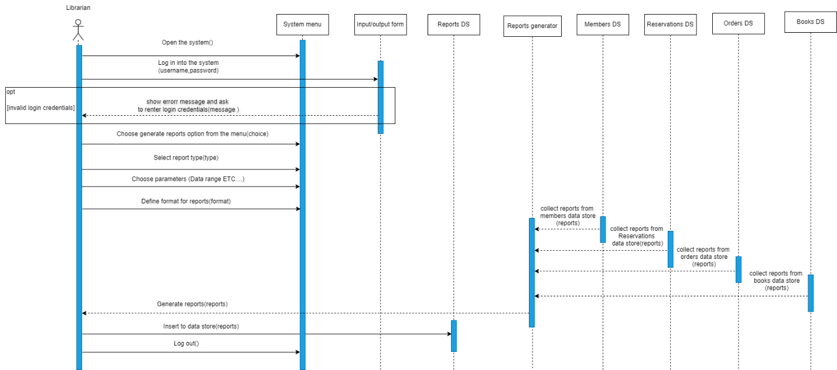

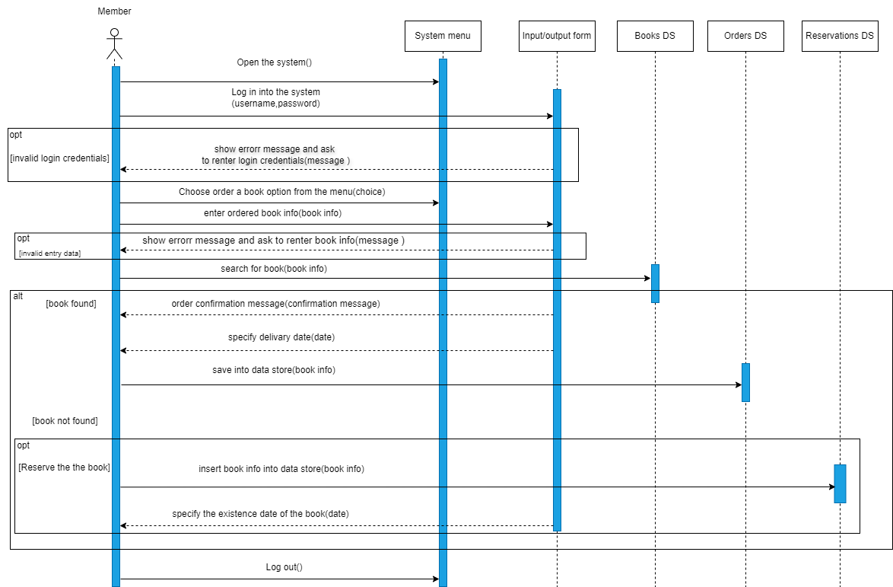**Order a book**

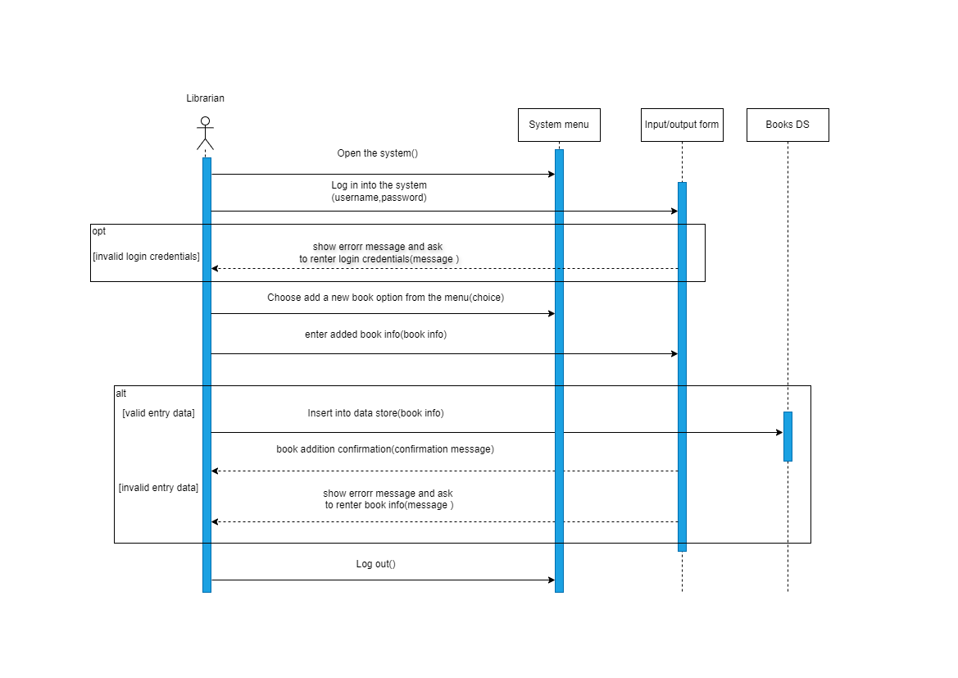**Add new book**

**8) Class Diagram**

